EXPERIMENT-2
Explore Git and Github Commands
Aim: To understand the fundamentals of Git and GitHub and perform basic version control operations using commonly used Git commands.
Theory:
Git is a distributed version control system for tracking source code changes locally.
GitHub is a cloud platform for hosting Git repositories and collaboration.

Software Required:
Git
Git Bash/Terminal
GitHub Account
Internet connection

Procedure:
Step 1: Install Git Download and install Git from the official website.

Step 2: Verify Git Installation
Execute the following command:
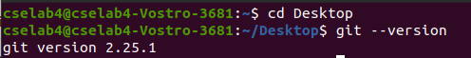

If Git is installed successfully, the installed version will be displayed.

Git Commands
- git init:
- It Creates a new Git repository in the current directory.
- Creates a hidden .git folder.
- Initializes version control for the project.

- git status:
- It Displays the current state of the repository.
- This command displays:
- Which branch you are on.
- Whether there are any changes.
- Which files are tracked or untracked.
- What is ready to be committed.
- On branch master: repository is currently on the master branch. A branch is a separate line of development in Git.
- No commits yet: A commit is a saved snapshot of your project. Git repository has been initialized but nothing has been saved permanently.
- Untracked files: Git has found files in your folder, but it is not tracking them yet.
- Git color meanings:
- Red- Untracked files
- Green- Staged Files
- White- Tracked & unchanged

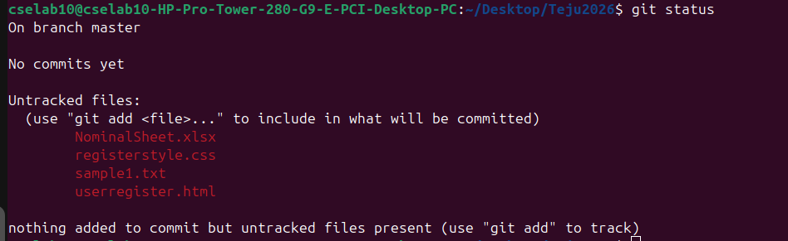

- git add:
Moves files from Working Directory to Staging Area.
- Single file: git add file1.pdf
- Multiple files: git add file1.pdf file2.css file3.docx
- All files: git add .
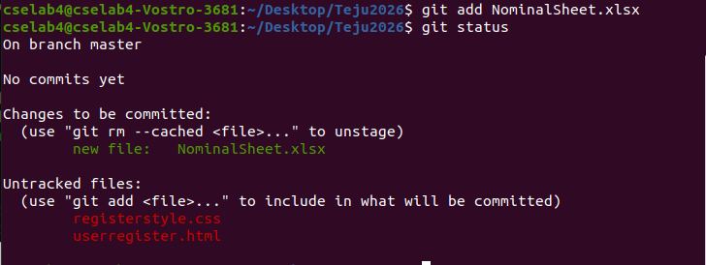

- git config:
It is used to configure Git settings, such as your name, email address, default editor, default branch name, aliases, and many other preferences. When you make a commit, Git stores information about who made the commit. That's why configuring your name and email is usually the first step after installing Git.
Syntax: git config [options] <key> <value>

System Configuration (--system): It applies to every user on the computer. It is stored in the Git installation directory. It requires administrator privileges.

git config --system user.name "Admin"

Global Configuration (--global): It applies to only one user account on the computer.
git config --global user.name "Tejasvi"
git config --global user.email tejasvi@gmail.com

Config list: It displays all the configured users and email address.

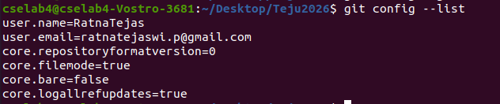

- git commit:
- A commit is like taking a snapshot or checkpoint of your project at a particular moment. It permanently saves the changes that are in the staging area into the Git repository.

git commit -m "change description”
Here,
git commit → Saves the staged changes.
-m → Allows you to provide a commit message.
"Change description" → Describes what changes were made.

- Instead of creating multiple copies, Git stores the history as commits.
- Master: current branch where the commit was made.
- (root-commit): Every Git repository starts with exactly one root commit. This is the first commit in your repository.
- Commit ID: Every commit gets a unique identifier. Even if two people make the same changes, Git generates different commit IDs.
- Commit message: It explains what was saved in this commit
- The file is permanently stored in Git.
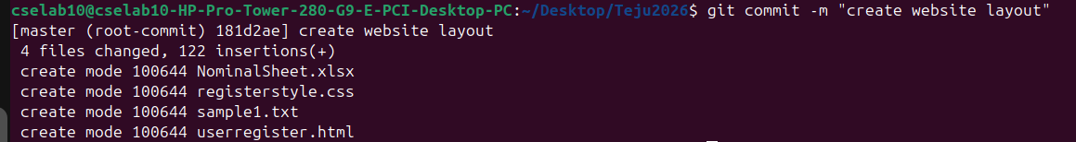

- git log:
It displays the complete commit history.
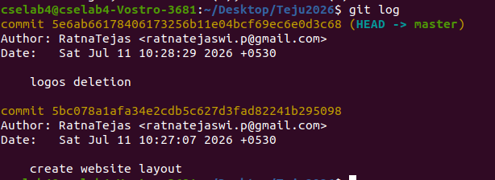

- git branch:
- The git branch command is used to view, create and delete branches

View Branches:
- master is the current branch.
- indicates the branch you are currently working on.

Create Branches: The branch was created and you are still on master.
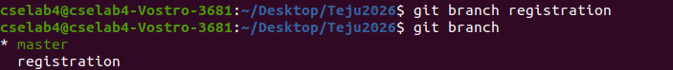

- git checkout: It is used to switch between branches.
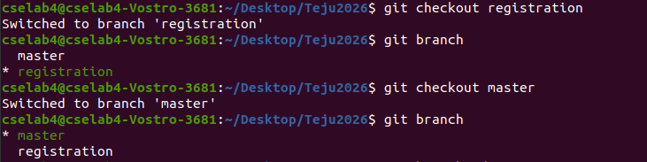

- Delete Branches
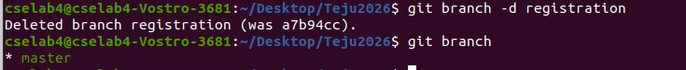
-d means delete

- A new branch(alterations) is been created and edited data in one of the file
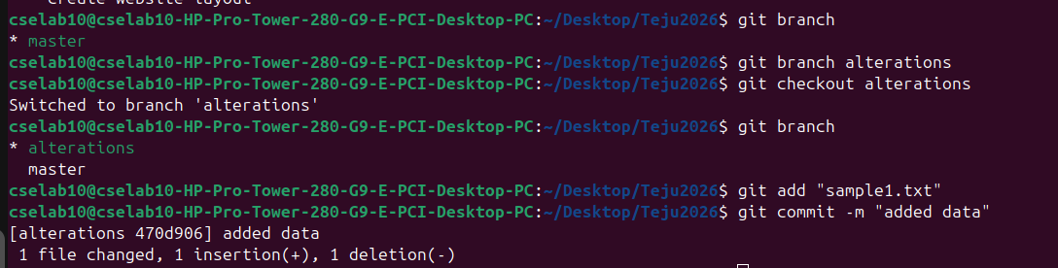

- git push:
- It uploads local commits to a GitHub repository.
- Connects the local repository with GitHub.
- Uploads commits to the remote repository.
- Sets the upstream branch for future pushes.

Step 1: Add Remote Repository
git remote add origin <repository_url>

Step 2: Push Repository
git push -u origin master

- git rm:
It removes files from Git tracking.
Command: rm -rf .git

